CSIS 330 – Lab 5: Packet Tracer Use of the TCP/IP Protocols and the OSI Model

*[Adapted from Cisco Networking Academy Network Fundamentals]*

**Background:**

In Packet Tracer simulation mode, detailed information about packets and how they are processed by networking devices may be viewed. Common TCP/IP Protocols are modeled in Packet Tracer, including DNS, HTTP, TFTP, DHCP, Telnet, TCP, UDP, ICMP, and IP. How these protocols are used by networking devices in creating and processing packets is displayed in Packet Tracer, using a representation of the OSI Model. The term protocol data unit, or PDU, is a generic description of what are known as segments at the transport layer, packets at the network layer, and frames at the data link layer.

**Help Files and Tutorials:**

From the pull down menu, choose **Help->Contents**. A web page will open. From the left frame, choose **Operating Modes->Simulation Mode**. If not already familiar, read about simulation mode.

**Realtime and Simulation Modes:**

In the far lower right of the PT interface is the toggle between Realtime and Simulation mode. PT always starts in Realtime mode, in which networking protocols operate with realistic timings. However, a powerful feature of Packet Tracer allows the user to "stop time" by switching to Simulation mode. In Simulation mode, packets are displayed as animated envelopes, time is event driven, and the user can step through networking events. To switch from Realtime mode to Simulation mode, click the **Simulation** mode icon. To switch from Simulation mode to Realtime mode, click the **Realtime** mode icon.

**Assignment Instructions:**

*[A Word template is provided for your screen shots.]*

1. **Add the following devices to the Logical Workplace, with about an inch between them, in order from left to right:**

* a server
* a PC

1. **Change the Display Name for each device.**

Change the display name for each device using the convention of **your first name**, **followed by an underscore**, followed by the device name and number that was pre-configured for you. This is the same convention that was used in the previous lab assignment and will be used throughout this course.

1. **Configure IP addresses, subnet masks, and gateway addresses**

**Server**

IP addresses are necessary for communicating over a network. Each device on the network must have an IP address assigned to it in order to communicate with other devices on the network. You will learn about IP addresses in more detail in a later module. For now, you only need to type in the IP addresses as illustrated.

Click the **Server** device to open the **Configuration** dialog. Click the **Config** tab and enter the Gateway IP address as shown below:

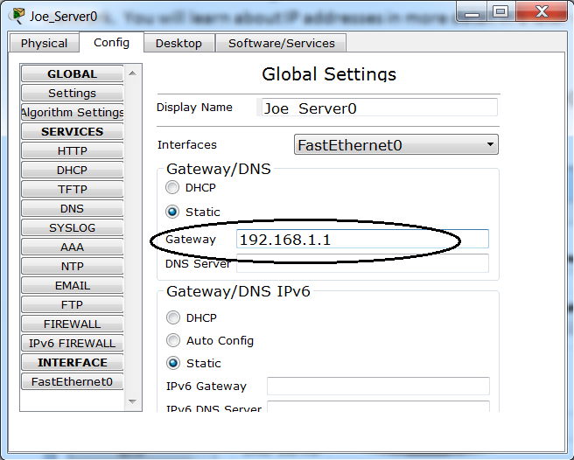

Next, click the FastEthernet0 button on the left and enter the IP address and Subnet Mask as shown below:

[Note that as soon as you enter the IP address and hit the [tab] key, Packet Tracer should automatically fill in the Subnet Mask address for you. ]

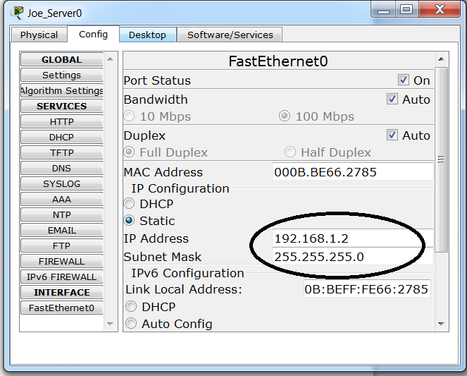

Close the dialog box. You should now be back at the Logical Workplace.

**PC**

Click on the PC device to pull up its Configuration dialog.

On the Config tab, enter the information highlighted in the next two diagrams:

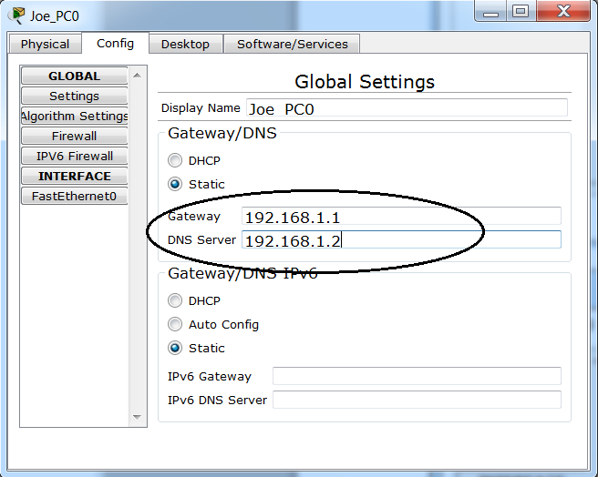

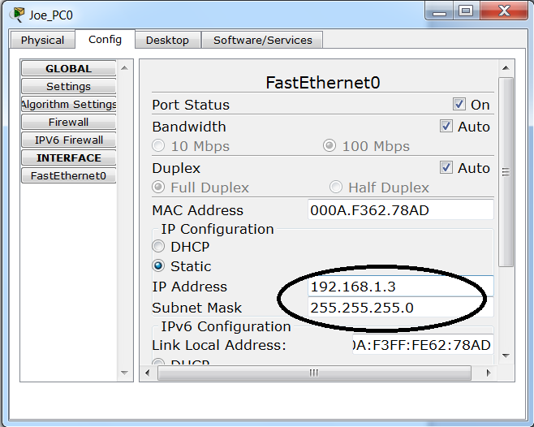

Close the dialog box. You should now be back at the Logical Workplace.

1. **Connect the PC to the Server using the Auto Connect icon**

The Auto Connect feature was described in Lab 1. You can refer to Lab 1 to review instructions for connecting devices.

1. **Creating a Packet and Accessing the PDU Information Window**

Click the PC device on the Logical Workplace. Choose the **Desktop** tab. Open the **Web Browser**. Enter the IP address of the Web Server into the browser’s URL textbox: 192.168.1.2. Clicking **Go** will initiate a web server request. Your screen should now look similar to the screen shot below.

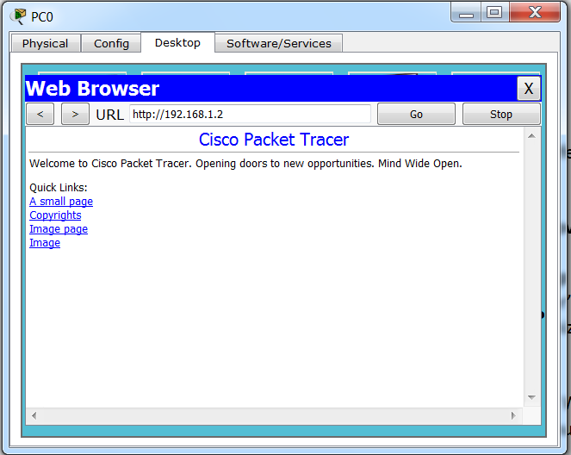

Minimize the Web Client configuration window by clicking the minus sign in the upper right hand corner of the window.

Now, it is time to view the packets traveling between the PC and Web Server in Simulation mode. Click the Simulation button in the lower right corner of your screen.

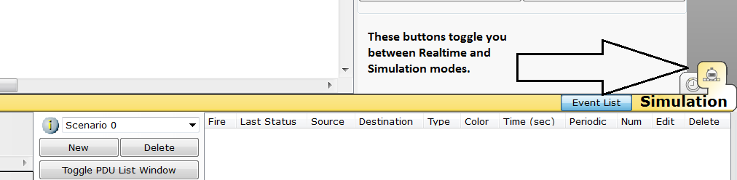

Now that you are in Simulation Mode, you must reissue the command to retrieve the web page before you can capture the packets in this mode.

Go back to the Web Browser. It should still show the URL that you entered in the previous step. Click the **Go** button and minimize the browser again.

Since time in simulation mode is event driven, you must use the **Capture/Forward** button to display network events. Two packets should now appear in the event list, one of which has an eye next to it. An eye next to a packet means it is displayed as an envelope on the logical topology.

At this point, your screen should look something like the one below:

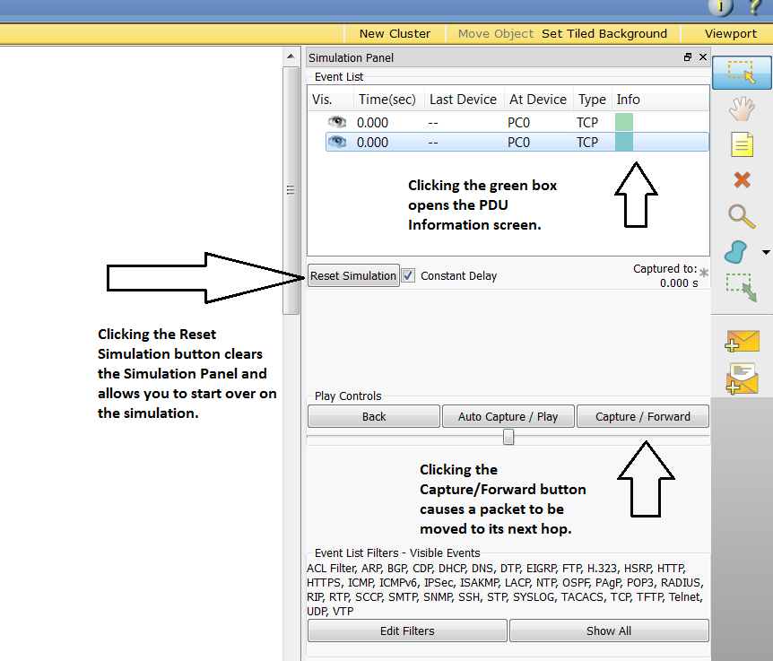

Continue clicking the Capture/Forward button until you see a packet displayed in the Simulation pane that has “HTTP” listed under the Type column. [You may need to click the button 2-3 times for this row to appear.]

Find the **FIRST** packet in the **Event List that has HTTP listed as its Type.**

Next, click the colored square in the **Info** column of that packet.

This opens the **PDU Information** window. Your screen should look something like the one below: Note that the diagram below reflects the **second** packet in the list. Your assignment requires you to open the PDU Information window for the FIRST packet with an HTTP Type.

The screen opens with the OSI Model tab displayed.

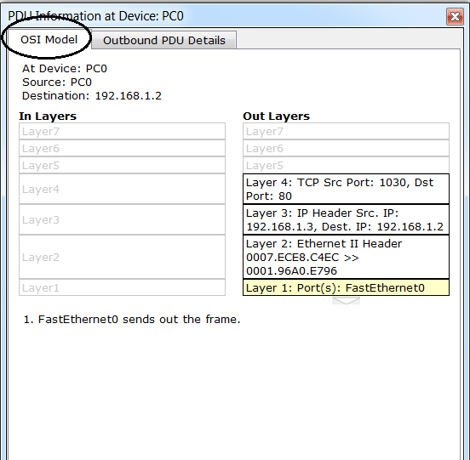

**Take a screen shot of this PDU Information window with the OSI Model tab open and paste it into the appropriate section (Screenshot #1) of the Word Answer Template provided.** **Put a title above your screen shot called “PDU Information – OSI Model tab”.**

The OSI model organizes this window. In the case of the packet you are viewing, notice the HTTP request (at Layer 7) is then encapsulated, successively, at Layers 4, 3, 2, and 1. If you click through these layers, the algorithm used by the device (in this case, the PC) is displayed. View what is going on at each layer--this will be the subject of much of the rest of the course.

1. **Inbound and Outbound PDUs**

Next, click on the Outbound PDU Details tab. This tab shows you the content and structure of the information included in the packet as it travels throughout the network.

Scroll down to the bottom of this window. There you will see that HTTP (the web page request that started this series of events) is encapsulated as data in a TCP segment, which in turn is encapsulated in an IP packet, which in turn is encapsulated in an Ethernet frame, which in turn is transmitted as bits on the medium. If a device is the first device involved in a series of events, packets at that device will only have an **Outbound PDU Details** tab; if a device is the last device in a series of events, packets at that device will have only an **Inbound PDU Details** tab. In general, you will see both Outbound and Inbound PDU details, which give details about how Packet Tracer is modeling that device.

**Take a screen shot of this PDU Information window with the Outbound PDU Details tab open and paste it into the appropriate section (Screenshot #2) of the Word Template**. **Put a title above your screen shot called “PDU Information – Outbound PDU Details tab”.**

**Using your screen shots, answer the following questions in your template**:

1. **On the OSI Model tab, what is the Destination Port specified in Layer 4?**
2. **At the bottom of the Outbound PDU Details tab, what command is shown in the HTTP box?**
3. **How many bits long is the IP frame?**

Run through the entire animation until the "No More Events" message is reached.

1. **Save your work**.

Following the naming convention described in your first Packet Tracer lab, save your **Packet Tracer** file as a “pkt” file:

[your first initial + your last name + “_Lab5” (do not include the quotation marks)

For example: Joe Smith will save his Packet Tracer file as JSmith_Lab5.pkt .

Save your **Answer Template** using the convention of [your first initial] + your lastname + “_Lab5”.

For example: Joe Smith will save his file template as JSmith_Lab5.doc .

**Deliverables**: Submit your assignment by attaching your PKT file and your Answer Template to the appropriate assignment link in Blackboard. Both files must be uploaded to receive full credit for this assignment.